**Country Program**

Syria

**Accused**

Name: Salem Salman

Photo:

N/A

Physical Description: 166 cm tall

Distinguishing Features: N/A

Date of Birth: N/A

Age: ~20 years old

Sex: Male  
Place of Residence: Refugee Camp (?)

Occupation: N/A

**Arrest**

Date of Arrest: December 13, 2018

Location of Arrest: Place of Residence

Arresting Officer: N/A

Crime being accused off: Sodomy

**Accuser**

Name: N/A

Age: N/A

Sex: N/A

Other Details: N/A

**Detention**

Current Detention: Either Bakri Detention Center or Aleema

Detention Center Contact: Saiid Bakri (Bakri)

Special Note: N/A

Moved here: N/A

Signs of Torture: N/A

Previous Detention: N/A

**Status**

Trial Date: N/A

Detention: N/A

Sentencing Terms: N/A

Release: N/A

**Public Defender**Name:Rahul Abboud  
Photo: 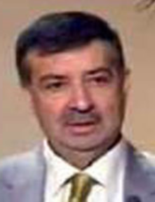  
Affiliation: Syria Bridges to Justice Lawyer

**Prosecutor**

Name: N/A

Special Note: N/A

**Judge Assigned to Case**

Trial Judge: N/A

Special Note: M/A

**Case Contact**

Name: Anonymous

Affiliation with Accuse: N/A

Contact Information: N/A  
Address: N/A

First Contact: App using Anonymous names on Dec 13, 2018

Last updated on accused status: N/A

*Emergency Contact*

N/A

Special Note: N/A

**IBJ Case Supervisor**

Name: Helena Bakri

Affiliation: Staff, Syria Bridges to Justice

Contact Information: +9637015829, Helena_sbj@gmail.com

Last log-in: December 13, 2018